**Fly, Swim, or Drive**

It’s time to learn what nesting is in animation. When you create a movie clip instance in a Flash document, the movie clip has its own timeline. Every movie clip symbol has its own timeline. The movie clip’s timeline is nested inside the main timeline of the document. You can also nest a movie clip instance inside another movie clip symbol.

As an example we’ll talk about a car. To add wheels that rotate, you can create a movie clip for a car wheel, and create two instances of this movie clip. Then place the wheels on the car movie clip’s Timeline—not on the main Timeline. Then motion tween the car across the stage and when it’s tweening across the stage the wheels will turn too.

You decide on the content for this assignment, but it must move internally while it motion tweens across the stage. That means you need to create an animation that loops inside a symbol so it smoothly play infinitely. It can be key framed, shape tweened, or motion tweened internally.

First you will make a symbol that animates continually like a butterfly flapping wings, motorcycle wheels rotating, fins of a fish, or spaceship lights, etc. Next, you will take that symbol and move it across the stage by motion tweening.

This tutorial teaches you how to animate a butterfly in Flash. It walks you through the basic steps to achieve a nested animation.

1. Start off by opening a new flash file
2. Draw a circle and adjust it to a shape that looks something like below.

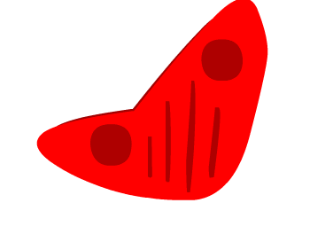

1. Add a new layer and name the first layer front wing and the second back wing
2. On the back wing layer make a copy of the wing shape and place it behind the front wing.

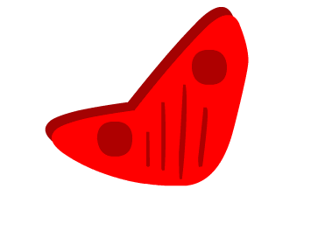

1. Now convert both wings individually to movie clips naming them accordingly.
2. Make sure the pivet point is set to the right side bottom corner as displayed or as desired to keep the wing moving in the correct direction.
3. Next, add a new keyframe in each layer and start adjusting the wings shapes downwards. Do this for about 5 frames each a little lower than the last. You can use the 3d tool here to create motion tweens instead of keyframing and add easing to get more of natural, realistic movement.

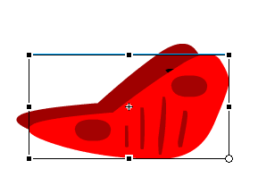

1. Highlight your frames, copy them, paste them in the next frame. You will reverse them now. Click on the top menu to **reverse frames** so the wings go back up smoothly. Your last frame should be identical to the first one. You can delete it if you prefer.
2. Finally, copy all frames of your timeline by highlighting and right clicking and select to copy frames.
3. Go to INSERT, NEW SYMBOL. Title it and choose movie clip as type.
4. Select the first blank frame and right click to paste frames. You have now created an internal animated symbol. When you place this symbol on a timeline it will play when you publish the swf file. You can add motion tweens and it will simultaneously tween and play internally.

Check the criteria on the website to make sure you are following the expectations.